Software Engineering

Trial Examination
2 hours 30 minutes including 10 minutes reading time.
Total 80 marks

Question 1
What is a key feature of progressive web apps (PWAs)? (1 mark)
- Require a constant Internet connection
- Can be installed like native apps
- Only work in Internet Explorer
- Do not use JavaScript
Choose one answer only
Question 2
Which language is typically used for client-side programming? (1 mark)
- PHP
- Python
- JavaScript
- SQL
Choose one answer only
Question 3
A common machine learning model for unsupervised machine learning is (1 mark)
- Logistic regression
- Linear regression
- Neural network
- K-Nearest Neighbour
Choose one answer only

Question 4
Match the definitions to the concepts (2 marks)
Term | Definition
1.decryption | A) Converts data into a fixed-length value that cannot be reversed
2.digital Signature | B) Security protocols that enable encrypted communication over a network
3.encryption | C) Data that has not been encrypted nor protected
4.hashing | D) Converts encrypted data back into a readable format
5.plain text | E) Converts readable data into a coded format to protect privacy
6.SSL/TLS | F) Used to verify the authenticity and integrity of a message

Question 5
Which of the following describe the Agile software development approach? (1 mark)
- It produces code faster than the Waterfall approach.
- It uses strict progression of steps through its life cycle.
- It uses an iterative workflow.
- It uses a software program called 'Agile'.
Choose as many answers as apply

Question 6
List 3 reasons why a web development team might use version control in the development of a website. (2 marks)

Question 7
Describe the difference between input validation and input sanitisation as defensive data input handling practices, providing an example of each. (2 marks)

Question 8
Explain 3 differences between front-end and back-end web programming. (3 marks)

Question 9
Tools and processes can be used to generate solutions for clients based on their requirements. Match the tools and processes given below to their definition. (2 marks)
Term | Definition
1.algorithm | A) A table which represents data items, their data types, format, size and validation rules if they apply.
2.data dictionary | B) A sequence of sketches or mock-ups to represent how users navigate through different screens
3.quality assurance | C) A set of processes or rules to be followed to solve problems.
4.source code | D) Checking if developed software meets requirements or specifications.
5.evaluation | E) A set of instructions written in a programming language to perform specific tasks.
6.storyboard | F) Performance of tasks to ensure that developed software continues to meet requirements.

Question 10 (4 marks total)
There are many different algorithms available for encrypting data, each with different strengths and weaknesses.
Part A
In which software development step would a software engineering team need to decide on the specific algorithm they will use? (1 mark)
- Requirements Definition
- Design
- Development
- Integration
Part B (3 marks)
Hashing algorithms are used to create a unique representation of data.
They have many uses in encryption and security.
Identify 3 essential features of a hashing algorithm.

Question 11 (6 marks total)
Which Machine Learning model is most appropriate for predicting new values based on the data given in the above graph?
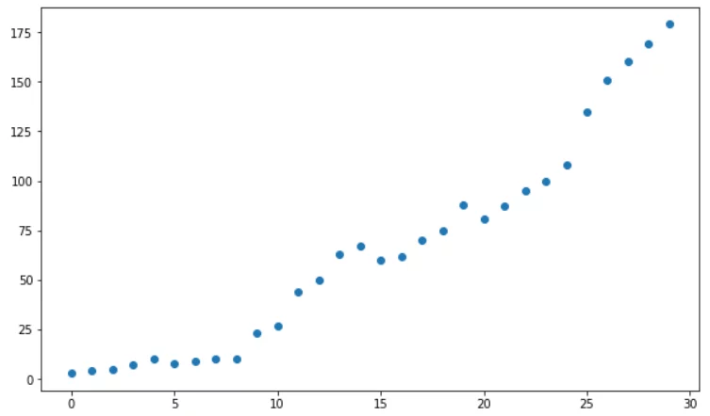
Part A
Which Machine Learning model is most appropriate for predicting new values based on the data given in the above graph? (1 mark)
- Decision tree
- Polynomial regression
- Linear regression
- K Nearest Neighbour
Choose one answer only

Part B
Explain why a Neural Network would not be the best choice of model for the training data in the above graph and propose an alternative Machine Learning model. (5 marks)

Question 12
Consider the following scenario:
An Australian aerospace startup is developing software to control its rockets from launch on Earth to space and to landing on other moons and planets.
Each rocket must have:
- A rocket ID, e.g. R20
- Launch site, e.g. “Broome”
- Provider ID which identifies the company that made the payload, e.g. P01
- The dry mass of the rocket, e.g. 2500kg.
- The wet mass of the rocket, e.g. 5250.50kg
- Target orbit, which describes the orbit the payload is to enter
- A release() command which will open up the payload doors and unclamp the satellite from the cargo bay.
In addition, each satellite must have:
- Satellite purpose, which describes the mission of the satellite
- Satellite targets, which describes what countries, regions or areas of the Earth or other planets or moons are to be monitored by the satellite
- A signal() command, which is used to establish and maintain communications control with the provider as indicated by the Provider ID.
Answer the question on the following page

Question 12 continued
Create a class diagram for the rocket and satellite relationship described in the stimulus. (3 marks)

Question 13
A local music store is using a database table called albums: (3 marks)
albumID | albumname | format | albumprice
A001 | Golden Hits | CD | 18.50
A002 | Live in Concert | Vinyl | 22.00
A003 | Acoustic Vibes | Digital | 15.00
A004 | Rock Legends | CD | 20.00
A005 | Chill Sessions | Vinyl | 25.00
Write an SQL query to show the output below.
albumame | albumprice
Chill Sessions | 25.00
Live in Concert | 22.00

Question 14
Consider the following algorithm:
01 BEGIN checkLogin (username, password)
02 IF username = "" OR password = "" THEN
03 PRINT "Username or password empty."
04 RETURN False
05 ENDIF
06
07 length = 8
08 symbol = ['#', '$', '!', 'ˆ', '&', '[', ']']
09 symbol_present = False
10 # Minimum username/password length is given in a global variable
11 IF LENGTH(username) < length OR LENGTH(password) < length THEN
12 PRINT "Username or password is not long enough."
13 RETURN False
14 ENDIF
15
16 # Check if the first character (at index 0) of both username and password is a letter
17 IF (isalpha(username[0]) AND isalpha(password[0]) THEN
18 # Check for the presence of at least one symbol in either username or password
19 FOR j FROM 0 TO LENGTH(username) - 1
20 IF username[j] IN symbol THEN
21 symbol_present = True
22 ENDIF
23 NEXT j
24 FOR j FROM 0 TO LENGTH(password) - 1
25 IF password[j] IN symbol THEN
26 symbol_present = True
27 ENDIF
28 NEXT j
29
30 IF NOT symbol_present THEN
31 PRINT "No symbol present in the username or password."
32 RETURN False
33 ENDIF
34 ELSE
35 PRINT "Username and password must start with a character."
36 RETURN False
37 ENDIF
38
39 // If all checks pass
40 RETURN True
41 END checkLogin
Answer the question on the following page

Question 14 (continued)
Write Python code that implements as the function has_symbol(username, password, symbols) only the part of the above algorithm that checks whether either username or password contains a symbol from the given list of symbols and also prints a message if this is not satisfied. (4 marks)
Question 15
Consider the following scenario:
Click Shoe Warehouse is an online store for Australian-made shoes. They want to know which of their shoe sizes and styles sell the best in each season. They have prepared a spreadsheet with 10 years of monthly sales history, organised by style and size.
Explain how Machine Learning and Business Process Automation can help ‘Click Shoe Warehouse’ achieve its goal. (4 marks):

Question 16
An online service wants to reduce the chances of user accounts being compromised by dictionary attacks. In this type of attack, an attacker uses a pre-defined list (often referred to as a "dictionary") of words, phrases, or common passwords to guess the victim’s password
Describe TWO strategies they could implement to reduce this risk. (4 marks)

Question 17
Web developers may use HTML and CSS or a CMS. Explain why an experienced web developer would choose to use HTML and CSS while a beginner would use a CMS. (4 marks)

Question 18
Assess positive and negative impacts of machine learning and artificial intelligence on production efficiency, waste and the environment. (5 marks)
Question 19 (6 marks total)
Consider the following scenario:
A library management system allows users to register online.
The registration form must collect user details and a secure PIN.
The PIN requirements are:
- Exactly 4 numeric digits
- No repeated digits (e.g. 1123 or 1231 is invalid)
- No letters nor special characters

Part A
Design a user interface for registration. Label all form fields clearly. (3 marks)

Part B
Explain how accessibility considerations improve the usability of web forms for a wide range of users, including those with disabilities. (3 marks)

Question 20
Describe the K Nearest Neighbour (KNN) algorithm for regression, predicting y for a new data point using a training data set of x and y values given the K value parameter of 3. (4 marks)

Question 21 (5 marks total )
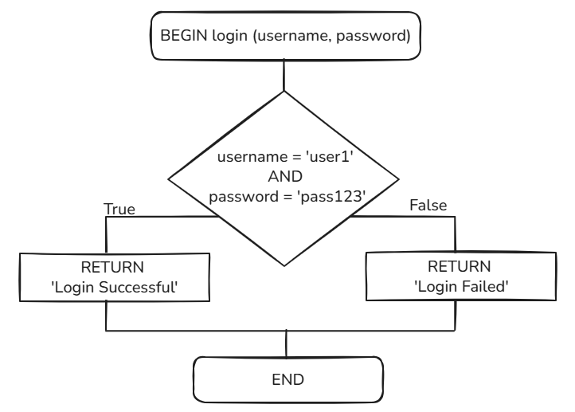
Part A (1 Mark)
The algorithm flowchart shown describes a stub for a login function.
Implement this stub in python code.

Part B (2 marks)
One simple test has been provided below.
Provide at least TWO more tests that could be used, with a comment justifying the use of each one.
# Test cases
IF login("user1", "pass123") == "Login successful" THEN
PRINT "Test case 1 passed"
ELSE
PRINT "Test case 1 failed"
Part C (2 marks)
You are tasked with writing an error message to return to users in situations where their login attempt fails.
This could happen when the password is entered incorrectly or when the username is incorrect.
What should you consider when creating these messages?

Question 22 ( 5 marks total)
Consider the following scenario:
An Australian toy manufacturing company has recently been established, with offices around the country. Toy manufacturing is subject to strict environmental, workplace health and safety, national and international regulatory frameworks, enforced by the agency AusToy.
Part A
Explain communications issues that may arise due to stakeholders being located all over the country. (3 marks)

Part B
Compare and contrast Hybrid (also called WAgile) and Waterfall software development methodologies in developing software to control the manufacturing of their toys. (2 marks)

Question 23
A popular social media platform has recently suffered a cross-site scripting (XSS) attack, leading to significant user data breaches and a loss of public trust.
Discuss the ethical, legal, and technical ramifications for both users and the enterprise stemming from such a security breach. (8 marks)

© State of New South Wales (Department of Education), 2025
The copyright material published in this resource is subject to the Copyright Act 1968 (Cth) and is owned by the NSW Department of Education or, where indicated, by a party other than the NSW Department of Education (third-party material).
Copyright material available in this resource and owned by the NSW Department of Education is licensed under a Creative Commons Attribution 4.0 International (CC BY 4.0) license.

This license allows you to share and adapt the material for any purpose, even commercially.
Attribution should be given to © State of New South Wales (Department of Education), 2023.
Material in this resource not available under a Creative Commons license:
- the NSW Department of Education logo, other logos and trademark-protected material
- material owned by a third party that has been reproduced with permission. You will need to obtain permission from the third party to reuse its material.
Links to third-party material and websites
Please note that the provided (reading/viewing material/list/links/texts) are a suggestion only and implies no endorsement, by the New South Wales Department of Education, of any author, publisher, or book title. School principals and teachers are best placed to assess the suitability of resources that would complement the curriculum and reflect the needs and interests of their students.
If you use the links provided in this document to access a third-party's website, you acknowledge that the terms of use, including licence terms set out on the third-party's website apply to the use which may be made of the materials on that third-party website or where permitted by the Copyright Act 1968 (Cth). The department accepts no responsibility for content on third-party websites.

